ANALYTIC HIERARCHY PROCESS (AHP) VALIDATION AND EVIDENCE DOCUMENTATION

1. Objective
The Analytic Hierarchy Process (AHP) was employed to determine the relative importance of the criteria used in the Smart Waste Severity Index (SWSI). AHP provides a structured multi-criteria decision-making framework that converts expert judgments into numerical weights while ensuring logical consistency.
The objective of this validation is to derive criterion weights, verify matrix consistency, and demonstrate reproducibility of the weighting process.

2. Criteria Selection
Four criteria were selected for severity assessment:
Criterion | Description
Waste Count (WC) | Quantity of detected waste objects
Waste Type Weight (WTW) | Environmental impact of detected waste categories
Location Sensitivity (LS) | Importance of the affected location
Historical Frequency (HF) | Frequency of recurring waste accumulation
These criteria collectively represent operational, environmental, and contextual dimensions of urban waste severity.

3. Pairwise Comparison Matrix
The pairwise comparison matrix was constructed according to Saaty’s AHP methodology.
Criteria | WC | WTW | LS | HF
WC | 1.000 | 2.000 | 3.000 | 4.000
WTW | 0.500 | 1.000 | 2.000 | 3.000
LS | 0.333 | 0.500 | 1.000 | 2.000
HF | 0.250 | 0.333 | 0.500 | 1.000
Evidence Source:
AHP_Validation.ipynb
Validation Type:
Actual Implementation Output
Reproducible:
Yes

4. Column Sum Calculation
Column sums were calculated to normalize the matrix.
Criterion | Column Sum
WC | 2.0833
WTW | 3.8333
LS | 6.5000
HF | 10.0000
Evidence Source:
Notebook Execution Output
Validation:
Actual Computation
Reproducible:
Yes

5. Normalized Pairwise Matrix
The normalized matrix was obtained by dividing each element by its respective column sum.
Criteria | WC | WTW | LS | HF
WC | 0.4800 | 0.5217 | 0.4615 | 0.4000
WTW | 0.2400 | 0.2609 | 0.3077 | 0.3000
LS | 0.1600 | 0.1304 | 0.1538 | 0.2000
HF | 0.1200 | 0.0870 | 0.0769 | 0.1000
Evidence Source:
Notebook Output
Validation:
Matrix Normalization
Reproducible:
Yes

6. Priority Weight Calculation
The priority weights were obtained by averaging the normalized matrix rows.
Criterion | Weight
Waste Count (WC) | 0.465819
Waste Type Weight (WTW) | 0.277140
Location Sensitivity (LS) | 0.161070
Historical Frequency (HF) | 0.095970
Weight Verification:
0.465819 + 0.277140 + 0.161070 + 0.095970 = 1.0000
Interpretation:
Waste Count (WC) received the highest importance, indicating that waste quantity has the strongest influence on severity assessment. Historical Frequency (HF) received the lowest weight while still contributing to overall decision-making.

Evidence Source:
AHP Notebook Output
Validation:
Priority Vector Computation
Reproducible:
Yes

7. Eigenvalue Analysis
To evaluate consistency, the weighted sum vector was calculated and divided by the priority vector to obtain the consistency vector.
The maximum eigenvalue was computed as:
λmax = 4.03103950215422
Evidence Source:
Notebook Execution Output
Validation:
Eigenvalue Calculation
Reproducible:
Yes

8. Consistency Index (CI)
The Consistency Index was calculated using:
CI = (λmax − n)/(n − 1)
where:
n = 4
Substituting values:
CI = (4.03103950215422 − 4)/(4 − 1)
CI = 0.010346500718073415
Evidence Source:
Notebook Output
Validation:
Consistency Index Calculation
Reproducible:
Yes

9. Consistency Ratio (CR)
For n = 4, the Random Index (RI) is:
RI = 0.90
The Consistency Ratio was calculated as:
CR = CI / RI
CR = 0.010346500718073415 / 0.90
CR = 0.011496111908970461
Evidence Source:
Notebook Output
Validation:
Consistency Ratio Calculation
Reproducible:
Yes

10. Consistency Verification
AHP consistency is considered acceptable when:
CR < 0.10

Obtained Result:
CR = 0.0115
Since:
0.0115 < 0.10
the pairwise comparison matrix is considered consistent.
Validation Result:
The AHP matrix is Consistent.
Evidence Source:
Notebook Output
Validation Type:
Consistency Verification
Reproducible:
Yes

11. Weight Distribution Analysis
The resulting weights indicate the relative influence of each criterion.
Ranking:
- Waste Count (WC) = 46.58%
- Waste Type Weight (WTW) = 27.71%
- Location Sensitivity (LS) = 16.11%
- Historical Frequency (HF) = 9.60%
Interpretation:
The framework prioritizes the quantity of waste detected while incorporating contextual and historical factors to support balanced decision-making.
Evidence:
Weight Distribution Plot
AHP Notebook

Validation:
Graphical Verification
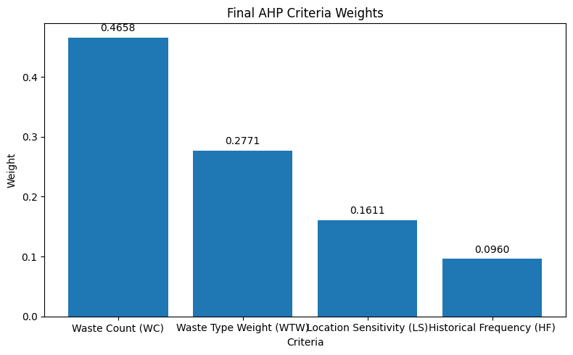
Reproducible:
Yes

12. Integration with SWSI
The validated AHP weights were directly incorporated into the Smart Waste Severity Index formulation:
SWSI = 0.4658(WC)
- 0.2771(WTW)
- 0.1611(LS)
- 0.0960(HF)
These weights were subsequently used for:
- SWSI Generation
- Severity Classification
- DBSCAN Hotspot Detection
- Resource Allocation
- Dashboard Analytics

Evidence Sources:
- AHP_Validation.ipynb
- SWSI.ipynb
- swsi_results.csv
- DBSCAN Notebook
- Resource Allocation Notebook

13. Result Traceability Matrix
Result ID | Output | Evidence | Validation Type | Reproducible
A1 | Pairwise Comparison Matrix | AHP Notebook | Matrix Construction | Yes
A2 | Column Sum Calculation | AHP Notebook | Mathematical Verification | Yes
A3 | Normalized Matrix | AHP Notebook | Normalization Validation | Yes
A4 | Priority Weights | AHP Notebook | Eigenvector Approximation | Yes
A5 | λmax | AHP Notebook | Eigenvalue Analysis | Yes
A6 | Consistency Index (CI) | AHP Notebook | Consistency Verification | Yes
A7 | Consistency Ratio (CR) | AHP Notebook | Consistency Verification | Yes
A8 | Weight Distribution Plot | AHP Notebook | Visual Validation | Yes
A9 | Final SWSI Weights | SWSI_Generation.ipynb | Framework Integration | Yes

14. Evidence Checklist
Evidence Item | Status
Pairwise Comparison Matrix | ✓
Column Sum Calculation | ✓
Normalized Matrix | ✓
Weight Computation | ✓
λmax Calculation | ✓
CI Calculation | ✓
CR Calculation | ✓
Consistency Verification | ✓
Weight Distribution Visualization | ✓
SWSI Integration | ✓
Traceability Matrix | ✓
Reproducibility Verification | ✓

Conclusion
The AHP framework successfully generated consistent and reproducible criterion weights for Smart Waste Severity Index computation. The obtained Consistency Ratio of 0.0115 is significantly below the accepted threshold of 0.10, confirming the reliability of the expert judgment matrix. The validated weights were integrated into the SWSI framework and subsequently utilized for hotspot detection, resource allocation, and dashboard-based decision support within the proposed smart-city waste management system.

